Arrange entries in alphabetical order by authors' last names or by title for sources without authors.

Book:
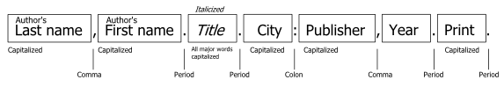
Website:
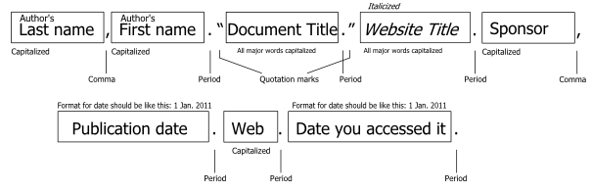
Video:
