NAME: __________________BOOK TITLE:__________________

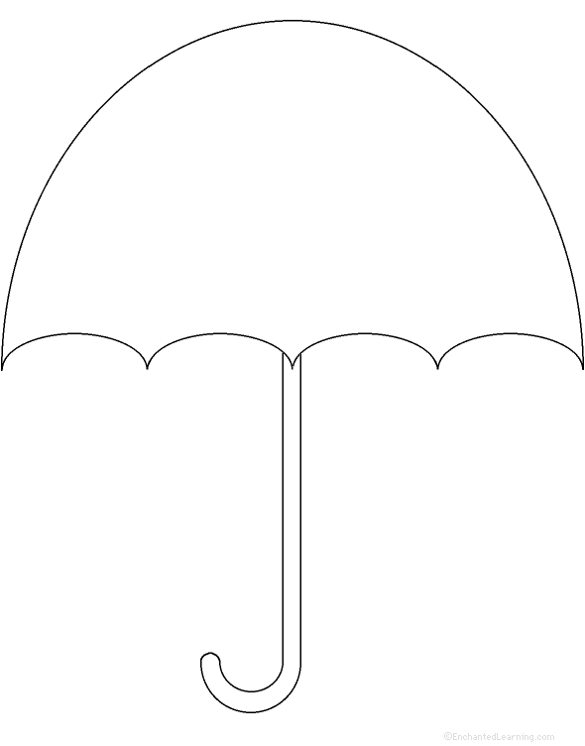
“
”
(Yes/No) Is this a lesson about life/human nature?
(Yes/No) Is this focused on the “BIGGER PICTURE?”
(Yes/No) Does this cover all of your evidence from the story?

THEME
Author’s “Hints”/ “Intended Messages”
“Where can you find these theme hints?”
Specific Quotes from the text WITH PAGE #
*Must support theme in umbrella.
1)

2)

3)

